In this we are going to be looking more and working deeper with SVG and vector graphics if you have done the last lesson we did a little cartoon animation using a single SVG file and animating separate elements of that SVG if you are not familiar with vector graphics this might be a little bit over your head you might want to get some experience first watch some Inkspace tutorials or get more friendly watch the latest and definately read previous lesson or some of the other Natron lesson we have done because we are gonna be going through this rather quickly So we want to create a user interface animation for a likes Phone app (who knows). We could just draw a whole thing in Inkspace but in interest of time and in case if you want to follow along we are just going to go pixabay and we are gonna find a user Interface vector Graphics so in Pixabay and we choose vectors as marked below

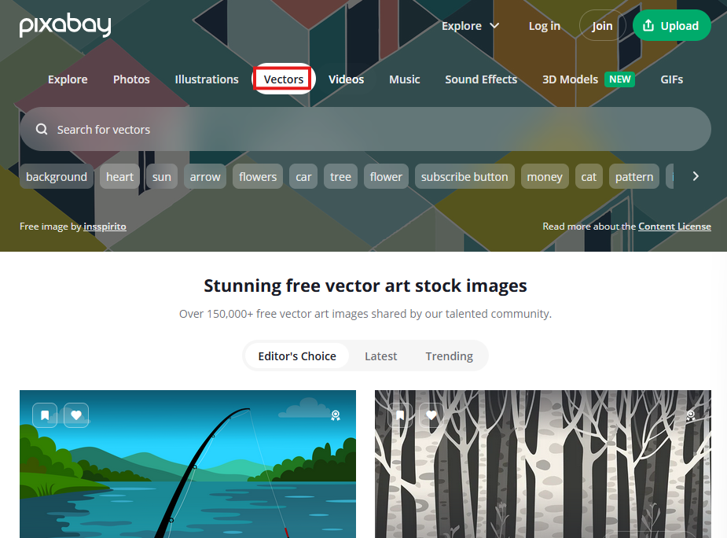

Teacher search UI we could not find it So I search it by trying keywords

So I searched Ui Phone and then we find the SVG file used by the Teacher as marked below

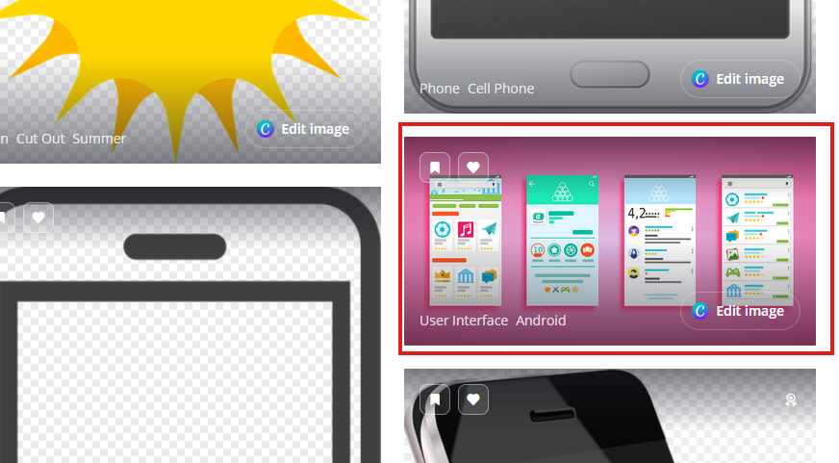

Now we click on it to open it

1:00

This image is free for use . When you download it then make sure you download the png image and download the vector graphic as marked below

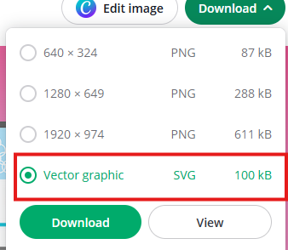

That’s gonna let us control and have be able to animate individual elements as opposed to one big picture.

Now we are going to download another vector graphic

Teacher search Phone and find his image but we could not find it so we search “titled blue phone” and find it as marked below

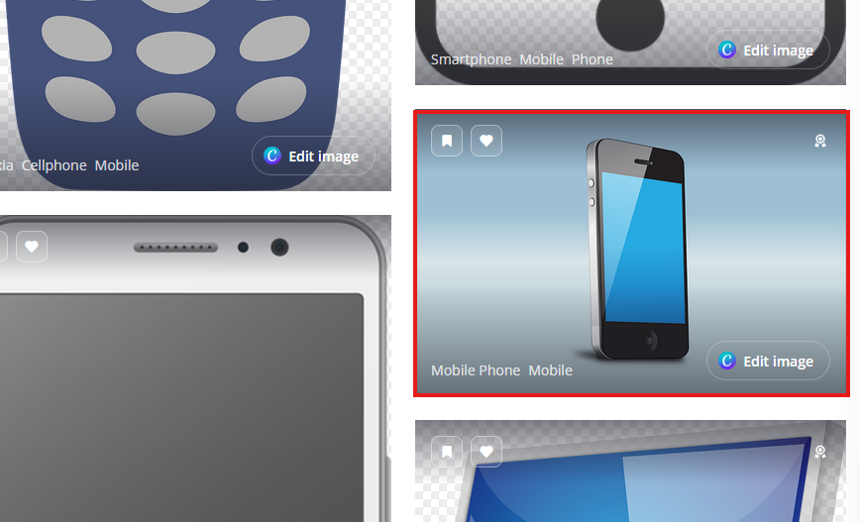

We are going to download this one as well as vector graphics but it is showing vector graphics as Adobe illustrator file

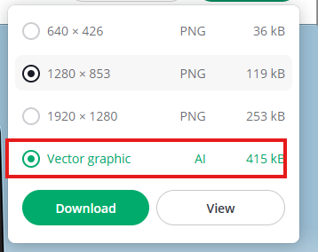

Which is fine because Inkspace is amazing and it can open all that. So if you don’t have an inskpace you can download that

Now you coul not open it manually as our PC don’t have Illustrator installed in it

But our userinterface file is svg which can br opened in Illustrator and in Inkspace or any other svg file

**Note:-**

You can zoom in in Inkspace by + key and zoom out by – key. Now we can see in Inkspace how it look like as shown below

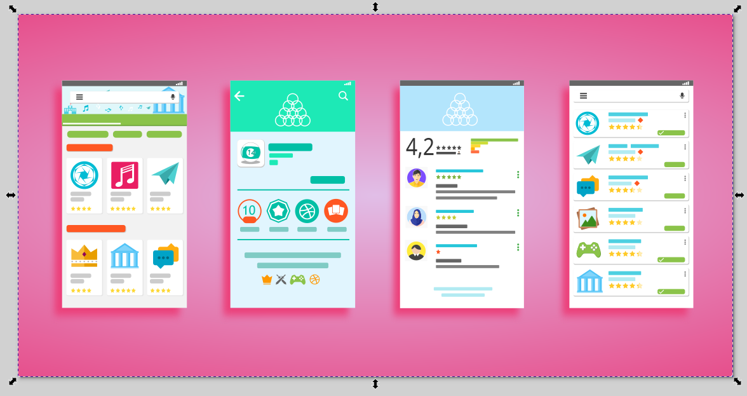

Now we ungroup it by ctrl + shift + g. we see a lot more selection lines appear as shown below

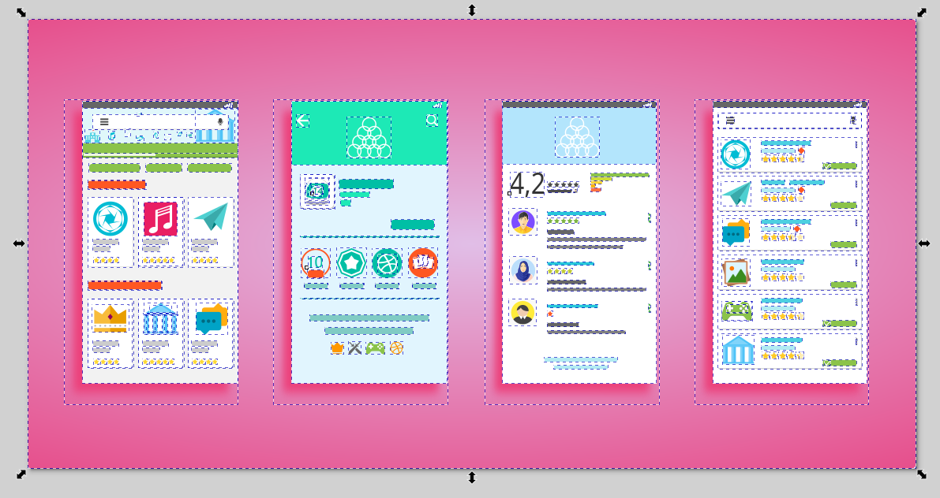

and now if we click on the background and move it independently. It will move as shown below

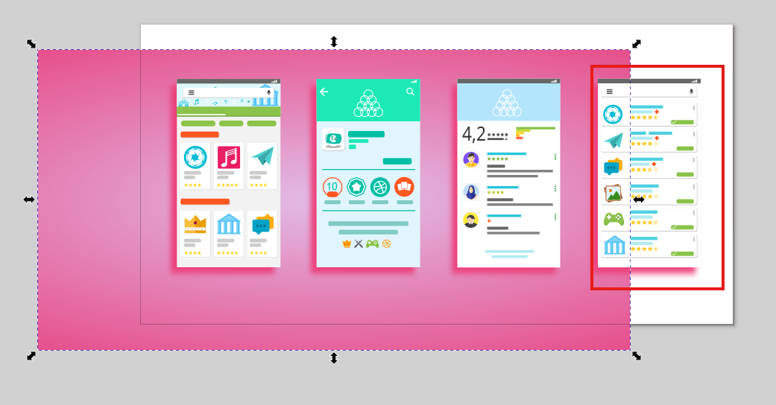

And everything is a whole complete separate thing which is cool so so we are gonna select the marked above and delete and select the background object and delete it because all we want to choose is one So we are going to choose one so we select everything leaving the third UI screen

Now our Inkspace screen look like below

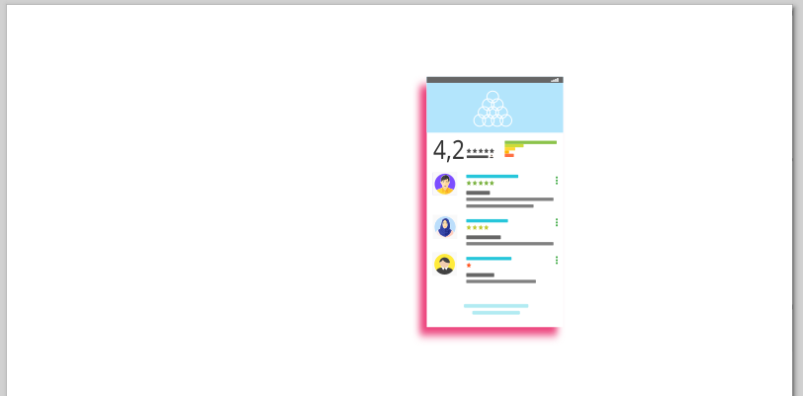

We don’t want the pink shadow of UI as shown above so I remove it. Now it look like below

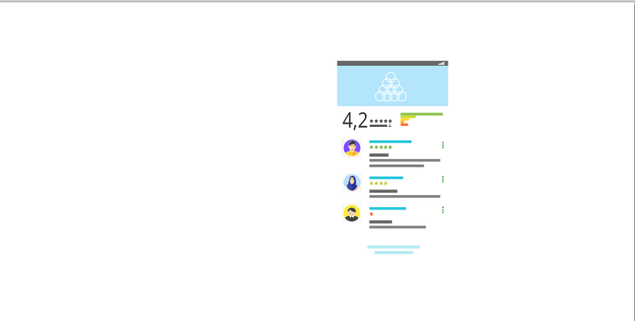

3:00

So now we have just single screenshot of like a user interface of maybe some rating , user reviews that kind of things that kind of so this is we are bringing into natron to animate and Teacher want to overlay on the top of that other phone screen but first of all look at the size of the above screenshot you can know it by seeing the top of the inkspace window after selecting the object as marked below

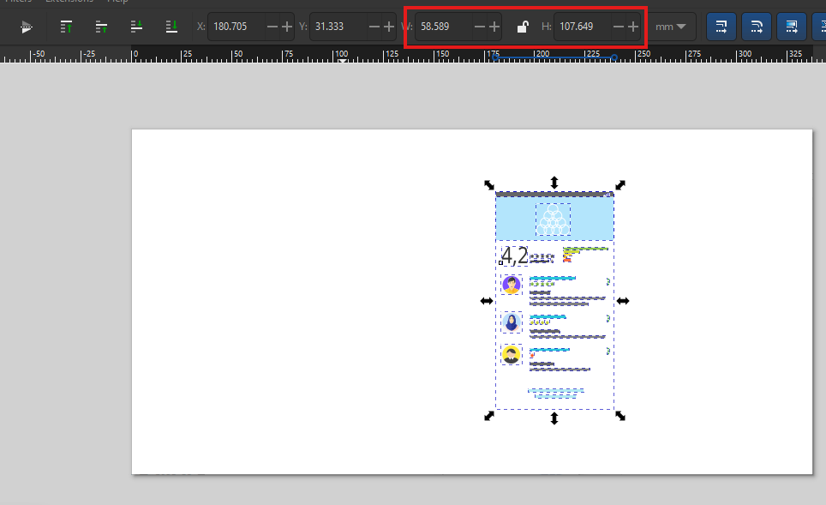

SO it is 58.5 X 107.6 Now we go to document properties by going to file and then to Document properties as marked below

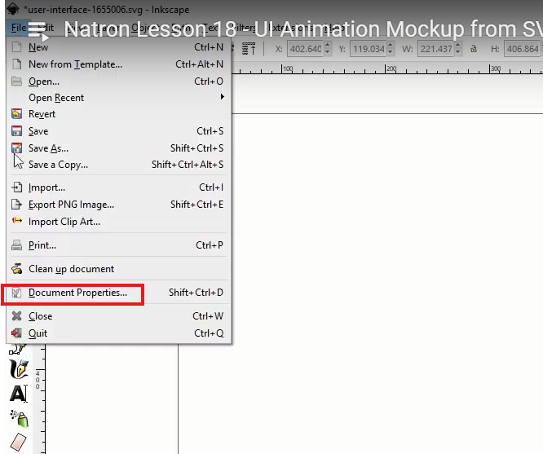

Now we make our document dimension equal to the size of the UI the remained Now our document properties window will be shown below

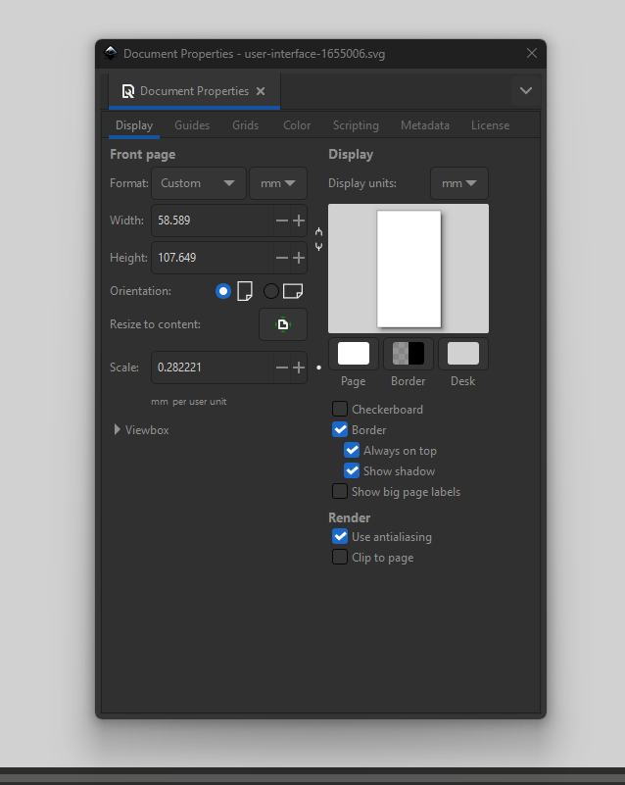

Now we copy and paste the remained UI screenshot width and height to the document properties width and height . Now document size is equal to the UI as shown below

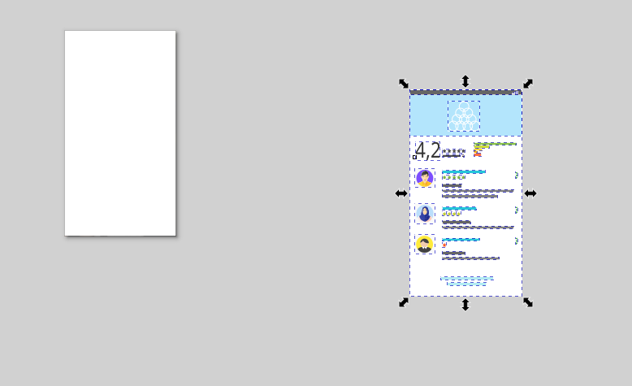

If we don’t do this otherwise when we export it and read it in the natron then its resolution will be equal to the document and the document part will be treated as a transparent and the UI will be treated as a part of the resolution of full screen but if we do it then the output resolution will be equal to the UI. And now we have a manageable size to work with (who knows)

Now we have all this element in our UI and now we need to choose the elements in Inkspace that we want to animate

4:23

Teacher is thinkning to animate the selected below

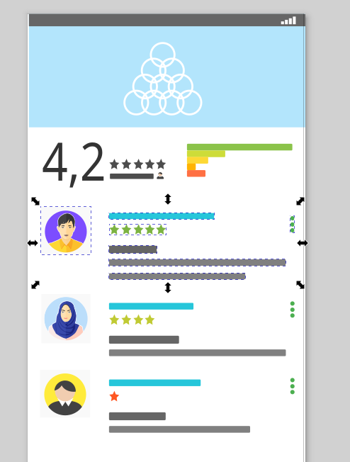

We will group it by ctrl + g and then we can animate it like sliding in from the side or coming up from the bottom so that’s a nice animation so we make individual all these three users so now we have three separate elements that we can control and everything else is going to be just big one group as highlighted below

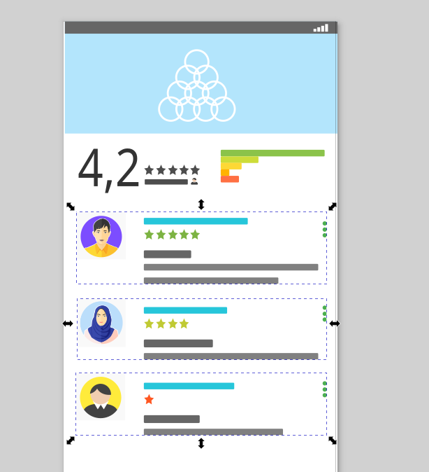

We will drag these off for now The Inkspace look like below

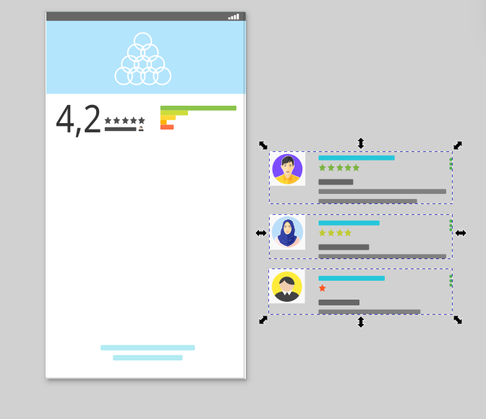

And now we group the other remaining UI materials as shown below

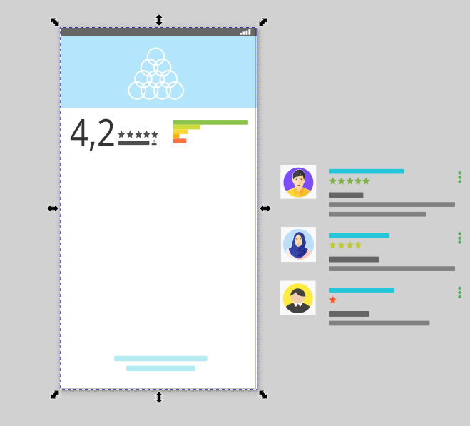

Now we go to layers menu and then in submenu go to layers and then in submenu go to Layers and objects and then it will open as a tab as shown below

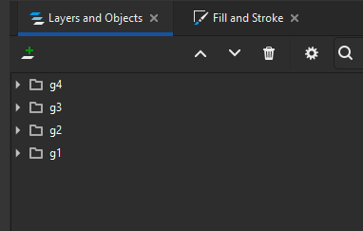

The programmer that made this just didn’t out any layers at all it just put everything in one layer and there’s different levels on each of other but there is not really typical specific layer we can see on the top

**Note:-**

In new version there is layer and objects and I think it shows object with their respective levels(as we have seen in Photoshop) as well as layers and in older version here was only layer panel in which I think only later was shown

So we click on add layer as marked below

5:17

Now

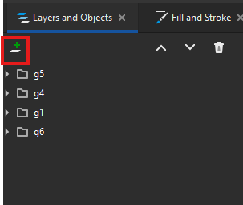

And now a new layer will be added in the panel below the parked we name it Background screen

Now you can see it added as shown below

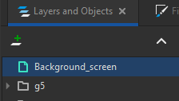

So this layer will be the background screen so we cut our UI background leaving the other three user and then select the background layer and then paste it there you will see that UI background is again visible but this time it is in background_screen layer or you can do just drag the object associated with the background_UI to the Background_screen layer and in both cases now out layer and object panel will look like below

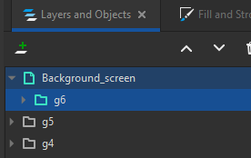

We add another layer and name it as user1 and inside it put the object as marked below

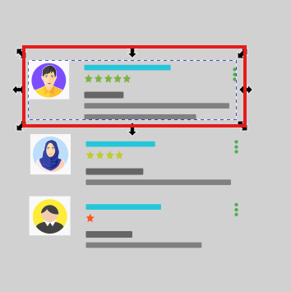

And then we make another layer that is user2 and put it in the second user and similar for third user We can accomplish this without doing this process that we are doing now but its gonna help us a lot to control So we are basically we are moving the object to their specific layer

**Note:-**

I think that layer group the objects and inside layers there are objects having their own individual levels

If you are confused then everything will make sense in Natron.

Now our Layers and objects panel will look like below

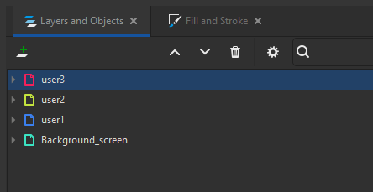

What we are trying to do is that avoid hundred different element that we are gonna be animating over top of this (maybe by grouping or making layers (who knows)) Now we bring the users back to their place Now our UI will look like below

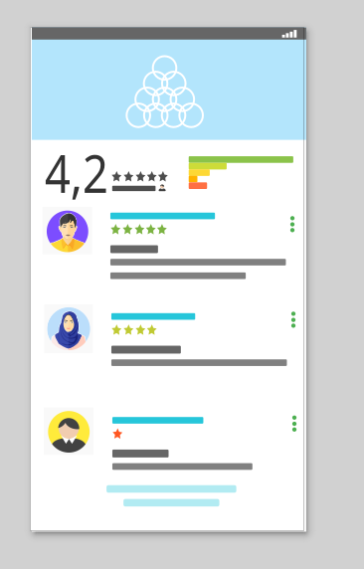

We can hide a layer by clicking on the eye icon beside it. So everything is on the correct layer that it needs to be and so now we are gonna exporting to save the whole things as an SVG file but since we opened the SVG file in Inkspace so we don’t need to export it just save it so it will be saved without any bg just one UI among four.

Lets open Natron now

7:26

And bring it in our natron by reading it we bring it by drag and drop method Now our UI look like below

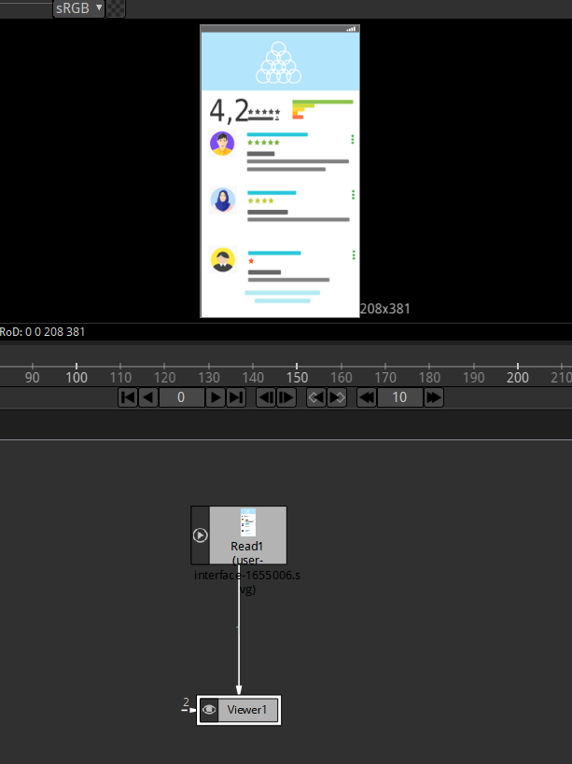

So we get this mobile interface in our Viewer. In the read section of read1 node in property panel we actually don’t have any options that we can read in certain parts of it as shown below

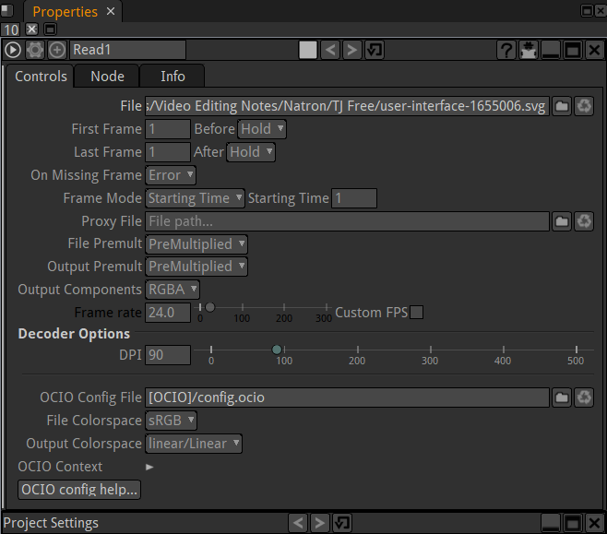

So we need to bring a merge node here for example so if we hit the M key on the keywboard and bring it on the merge node Now our node graph will look like below

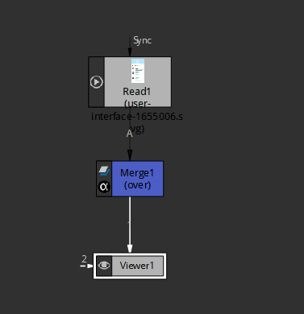

and now under the merge properties everything connected to the pipe A what do you want to display on that (who knows) Now we go to A layer in merge properties and you will see the list of whole element to which mobile UI is made as shown below

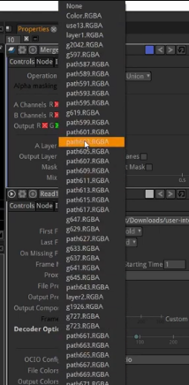

Here we have all different things or path for example if I choose an element you want to show suppose we choose path 211.RGBA but we want to use the groups that we created but we did not name it properly now we get the mobile background by choosing g6.rgba and we set this mobile UI as a background by connecting the B node of merge mode to the read1 node.

So our node graph and viewer look like below

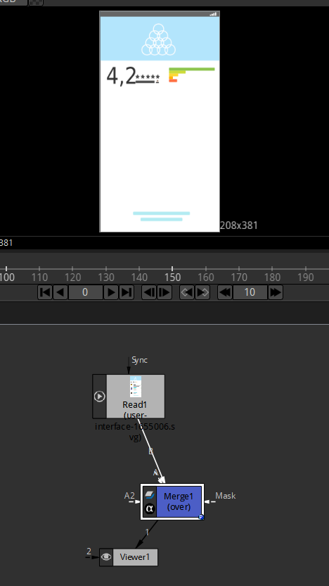

8:26

So we go to B pipe in the merge node and choose g6.rgba Now we copy and paste the Read node

And then link the duplicated read node to the marge node now disable the background read node since they are the same and in A layer choose the g1.rgba Now in vewer panel you can see that it look like below

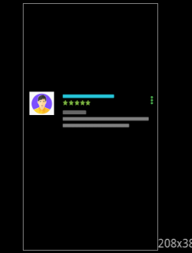

And now our node graph look like below

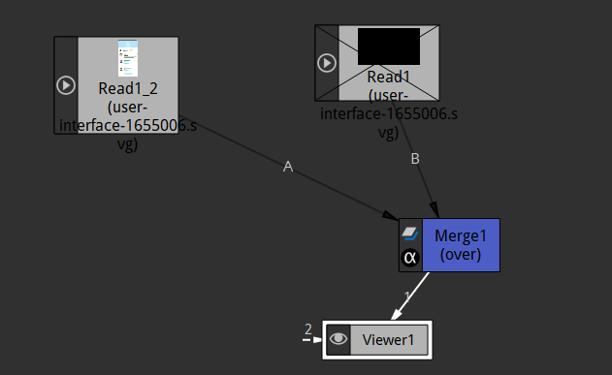

Now you can see user1 rating in our viewer But another way to do it since we did levels (who knows) we can actually find our level layers So I choose in A properties of merge node layer4.RGBA which is represent the user 1 we added before by g1.rgba Now the viewer the same it was looking before and that’s the reason teacher set up tha layers because it is kind of easier to find than looking at groups and paths and different things. Layer 5 is going to be a different review and therefore etc so let’s do lets grab all of the three users so we duplicate the read node two times more to represent remaining users review and then connect them to the A consecutive layers and then in merge node choose the layers representing the different user reviews

Now our node graph look like below

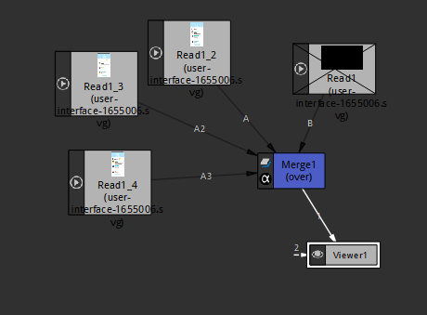

So you can see multiple thing or nodes are connected to merge node. Now our merge node properties look like below

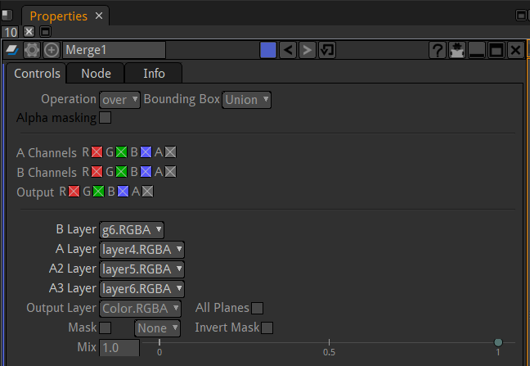

Now our viewer panel will look like below

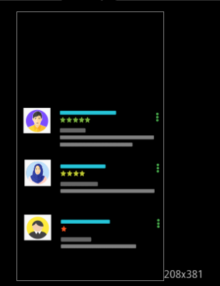

Now you can see there are many elements in our node graph which might be very confusing Now we enable the Read1 node now we have all the thing and viewer panel will look like below



To see what a node represent you can disable it and the thing that will be invisible is the thing which represent the node

We now rename the nodes Teacher name them user 1,2,3 representing different user reviews so I rename it according to my wish

Now we want to do is animate these in so let’s do this

11:15

So we add transform node top each read node by hitting T key now that we have transform node connected to each and every read node as shown below

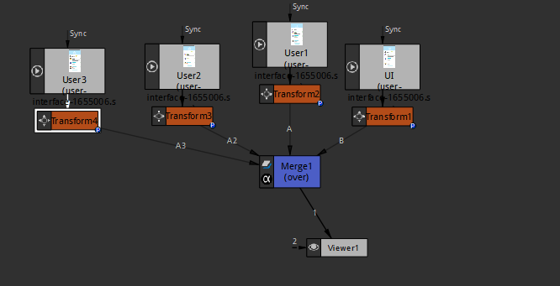

what we want to do is at very first we want to have no reviews and then have animate it very quickly so to do that and there is kind of slide in . Now I move the user reviews off the screen like below

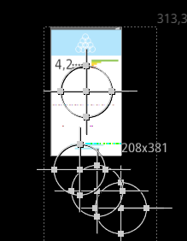

So we want to animate user 1 so go to translate in our transform properties and we set keyframe there at frame 1 and then we make one at keyframe 10 we move the usr1 back to its place as shown below

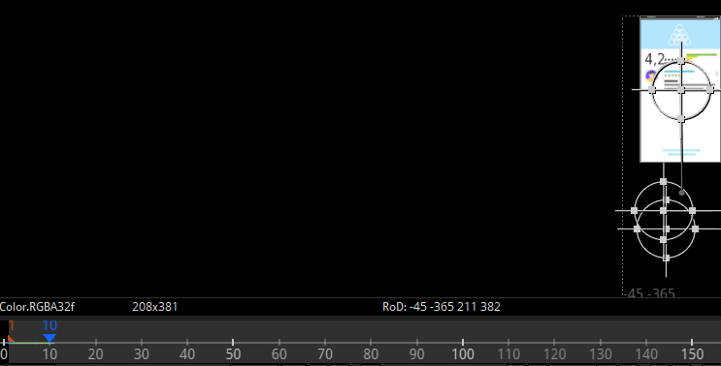

Now we have it to be animated all the way up to here as shown above

The user1 is looking like bit grainy but it won’t look like that when we actually do it and now we go to next user and we will keyframe it and we want to make sure we are aligning the second user with the vertical UI center as marked below so it comes directly straight up

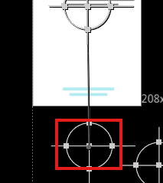

And then we set a keyframe there at frame 10 set keyframe for second user and then keyframe 20 move it to the correct position and then at keyframe 20 set keyframe for user3 and then at frame 30 move it to its correct place

**Note:-**

By centreX and centerY property we change the position of pivot

Now our animation look like below



Now you can see all the users are sliding up as shown above

14:11

Now we could place background around this mobile UI so we add another merge node that is attached to our previous merge node now our node graph look like below

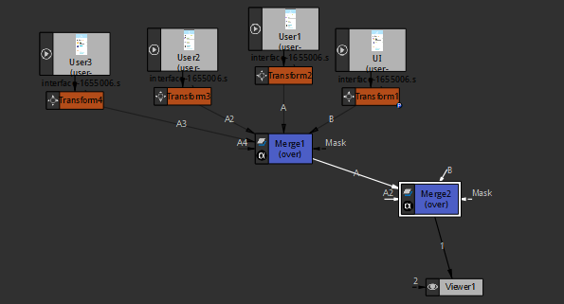

Now we add a shader toy to our new merge node as a background

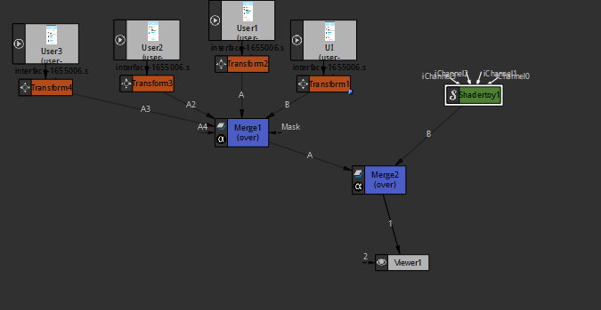

Now our node graph look like above Now we have a background now we go to project settings and set the resolution to 1920 X 1080 so that the background have the shader Toy

So we did as marked below

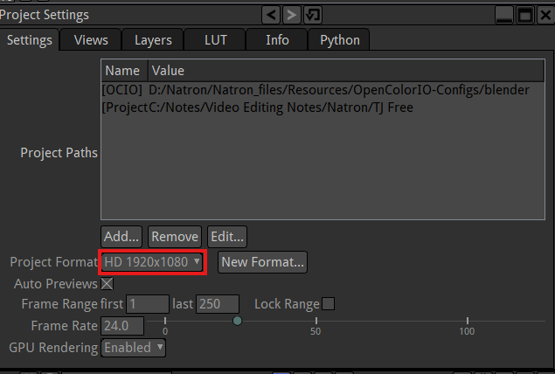

If you could not find project setting in properties panel then press **S** then it will appear or go to Display menu and then to show project settings option

Now you can see your project setting at the top

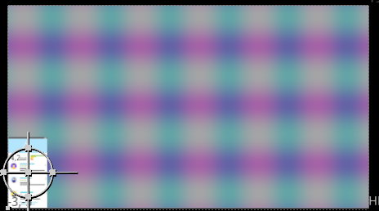

Now if you zoom out then you can see the bg behind our mobile UI made of Shader Toy. Now wwe add transform to the merge node handling the UI Now our node graph look like below

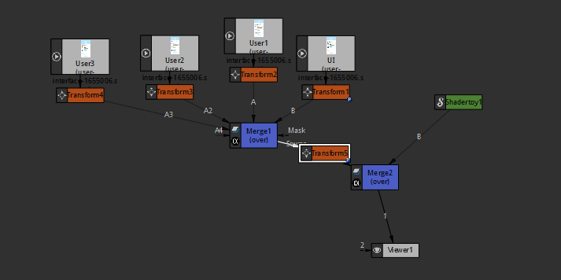

Now the transformation controls are overlapping so we separate out Shadertoy merge node transform by toggling its centreX and centreY to move it and separate it from other controls

We separate it as shown below

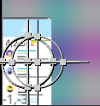

Now we move the UI and make it in the centre of the screen in viewport and then increase its size so now the viewer look like below

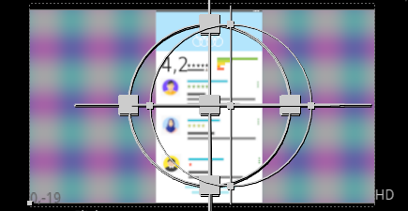

Now we change our shader Toy presets to source and then to Noise Animation Watery as shown below

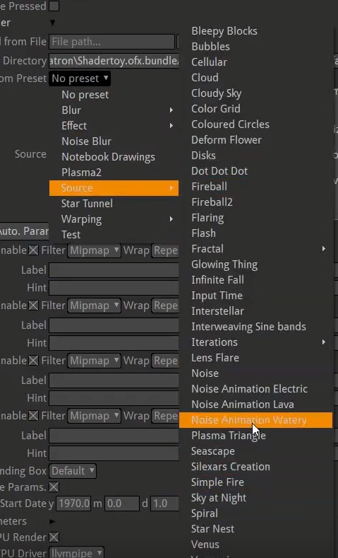

Now in viewport if you see the viewport now it look like below



You can see animation is going on in background and also in foreground.

And now the final thing we need to do

16:11

Just to get really crazy we are gonna bring in the other image(the image we downloaded is of ) well you know we are going to finish this lesson and in next lesson we are going to bring in the other image well you know what we are going to do the corner pin we are going to bring in the phone (smartphone image we downloaded ) which is at an angle as shown below

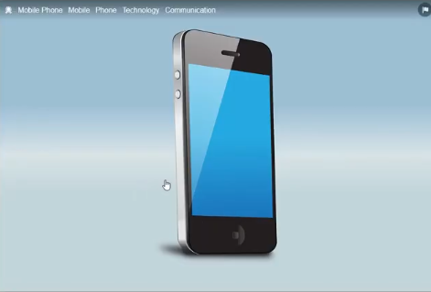

And we are going to change our thing in natron so its not a flat look directly on us but the UI we made is going to mapped in the phone above which Is a still image but its like a kind of precursorto like tracking and mapping a screen on top of an artificial screen (who knows).

So see you in the next lesson.